10 questions
1.What is the main topic of my PDF?

2. Explain the first topic in simple words.


3. Give me a short summary of the PDF.


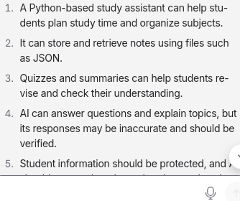
4. List five important points.

5. Give me five multiple-choice questions.
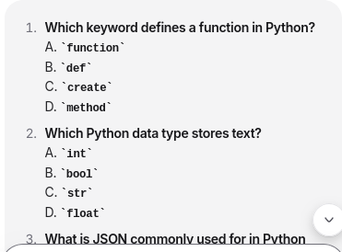

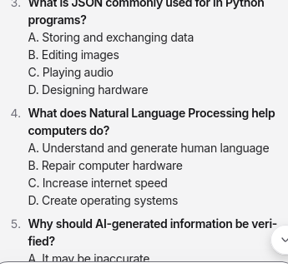

6. Explain one concept with an example.
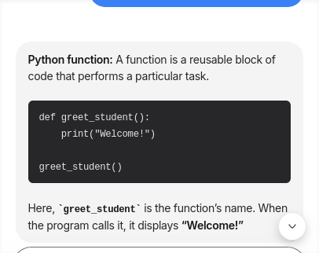

7. Prepare short revision notes.
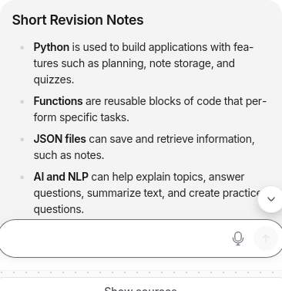

8. Compare two topics from my PDF.
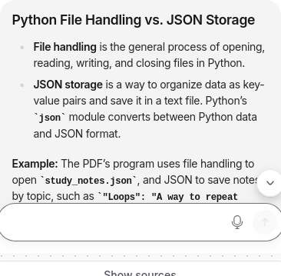

9.what is my name


10 .what is the largest planet in solar system


